**CUPE LOCAL 3905**

**Annual General Meeting 2018**

**March 29, 2018**

**LUSU boardroom (UC 2001)- Lakehead campus and OA 2005- Orillia**

**Agenda**

1. Call to order
2. Equality Statement
3. Roll Call of Officers
4. Presentation of agenda
5. Minutes of Last Meeting
6. Matters Rising
7. Treasurer's Report
8. Communications and Bills
9. Executive Committee Report
10. Nominations and Elections & Installations
11. Personal Development Bursary
12. Unfinished Business
13. New Business
14. Good of the Union

**Attendance**

**S/N Name Dept/Faculty**

1. **Anish Yadav**
2. **Ataie Minoo**
3. **Beery Steven**
4. **Benalcazar Vergara Paul Gonzalo**
5. **Brecka Aaron Francis**
6. **Chen Chen**
7. **Si Chen**
8. **Chen Qun Sunny**
9. **Chen Xinli**
10. **Chio Chon Long**
11. **Clutchey Christina**
12. **Dubreuil Robert**
13. **Eade Statton Frederick**
14. **Fossum Nicole Shauna**
15. **Grynko Oleksandr**
16. **Hisano Masumi**
17. **Hunter Colin**
18. **Ismail Ashiana**
19. **Kadikoff Wilfred Berek**
20. **Marchese Carlina**
21. **McEwen Charlotte Christina**
22. **Pascua Jeff**
23. **Pegg Samuel**
24. **Poladyan Harutyun**
25. **Robb-Mackay Ian Cameron**
26. **Ross Caicedo Ema Cristina**
27. **Priyank Sabhaya**
28. **Samavi Mahdieh**
29. **Sharma Hem Kanta**
30. **Silverio Vieira Ellen Caroline**
31. **Sista Kameshwar Ayyappa Kumar**
32. **Sony Sandeep**
33. **Tedla Binyam Abera**
34. **Searl Eric Bryan**
35. **Avoseh Jimmy**

**Order of Business and decisions:**

1. **Call to order:** Meeting called to Order by President Eric Bryan Searle at **05:05 PM**
2. **Equality Statement:** Read out by President, 05:06 PM
3. **Roll Call of Officers:** President Eric introduced all the executives, **05:09 PM**
4. **Accept agenda:** Agenda presented **05:10 PM**.

**Moved by**: Si Chen

**Seconded by**: Ellen Silverio Vieira

**Discussion**: None

**Approved. Carried**: All

1. **Minutes of Last Meeting:** Posted online in CUPE 3905 Site: Highlights Read out by President Eric. No further discussion.

Moved by: Aaron Brecka

Seconded by: Harutyun Poladyan

Minutes Accepted, Carried: All

1. **Matters rising: $5000 Donation to CSEB Conference Lakehead 2018 05:12 PM**

* Let it be considered that a donation of $5000 be approved towards CSEB Conference, Lakehead 2018

Motion Moved by: McEwen Charlotte

Seconded by: Clutchey Christina

Approved. Carried. All

1. **Treasurer's Report: 05:22 PM**

Financial Report Presented by **Steve Beery**

**Financial Statement May 2017 to April 2018**

Open balance of $46,540.34

$162,930.98 in income from dues and our mutual fund.

$107,737.89 in expenses

Total Surplus is $8,652.75

Retained earnings for 2017 /18 projected to be $55,193.75

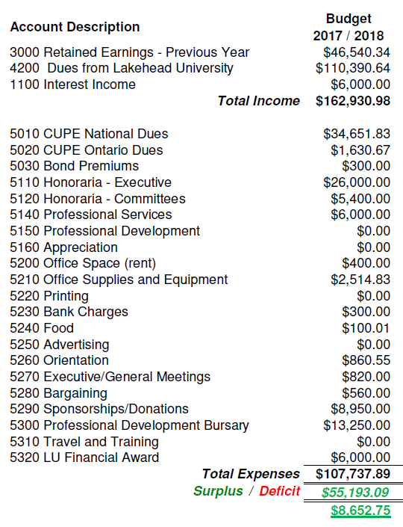

No discussion on this report

1. **Communications and Bills**

Presented by Si Chen

**Budget Committee: 05:24PM**

**Proposed Budget**

* Finishing the 2017 /2018 year in a surplus, carrying forward $51,564.50
* We are able to support 20 PDBs next year, including 5 additional PDBs
* Propose an operations budget of the $96,340.00 for 2018 /19; based on income from the average number of members over the last 3 years; 390.
* Anticipate a year end retained earnings for April 2019 of $49,492.21.

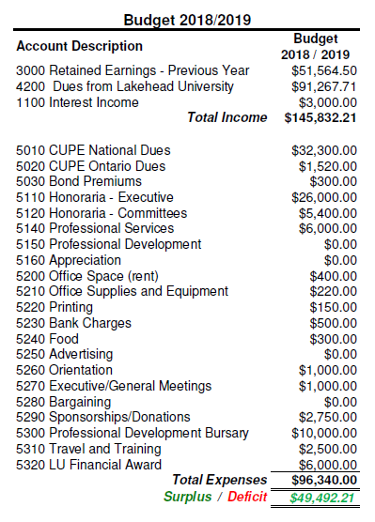

1. **Trustee’s report**: 05:26, Presented and Facilitated by President Searle Eric

* The Trustees of CUPE Local 3905 reviewed the 2017 / 2018 financial statements and found everything in order.
* Recommendations from the February 2018 Trustees’ Report has been implemented.
* The local’s digital and paper filing and financial reporting systems complies with CUPE National directives.
* All 3 Trustee positions are up for election.

1. **Business arising: 5:31PM**

Motion 1:

Be it resolved that CUPE Local 3905 provide Lakehead University with $6,000 to support the 2018/19 annual CUPE Financial Awards, 6 - $1,000 bursaries.

Moved by:

Seconded by Poladyan Harutyun

* Motion 2:

Be it resolved that CUPE Local 3905 increase the annual allocation of funds authorized by the bylaws for PDBs in 2018 /19 from 15 (fifteen) PDBs totaling $7,500 to 20 (twenty three) PDBs totaling $10,000.

Moved by: Marchese Carlina

Seconded by: Ellen Vieira

* Motion 3:

Motion to increase the annual allocation of funds authorized by the bylaws for PDBs in 2017/18 by $6,750 for a total PDB budget of $14,250 supporting 31 (thirty one) PDBs.

Moved by: Steve Beery

Seconded by: Chan Si

* Motion 4:

Motion to accept the proposed 2018 /19 Budget recommended by the Budget Committee.

Moved by: Jeff Pascua

Seconded by: McEwen Charlotte

* Motion 5:

Motion to accept the Trustee’s Report

Moved by: Aaron Brecka

Seconded by: Pascua Jeff

* Motion 6:

Motion to accept the Treasurer’s Report

Moved by: Ayyuppa Sista Kameshwar

Seconded by: Chon long Chio

1. **Executive Committee Report: 05:53**

**President’s Report**

Presented by Eric Searle

* Every executive member has done a great job. All executive positions are vacant from now. No any outstanding issues for GAs.
* Attended the Joint Health and Safety Committee meeting every month. No serious issues so far.
* Bursary fund for members with children, members living with a disability, and international members
* Consultation for Field School as part of GA duties

Moved by: Si Chen

Seconded by: Aaron Brecka

**Vice President’s Report: 05:56PM**

Presented by Steve Beery

Attended the Internal Relations Committee meeting every month.

Moved by: Harutyun Poladyan

Seconded by: Aaron Brecka

**Report of the Stewardship Committee: 05:59PM**

Presented by Steve Beery

Stewards for this year are as follows

* + Social Science and Humanities: AmandaLynn Mihalus
  + Natural Resource Management: Si Chen
  + Science and Environmental Science: AyyappaKumar SistaKameshwar
  + Health and Behavioural Science: Charlotte McEwen
  + Engineering: Niloofar Alipoormazandarani
  + Education: Bailey Giroux
  + Business: Sunny Chen
  + Orillia: Lynn Remmelgas, Luke Cuppage
* One complaint regarding breakdown of relationship with working supervisor

CUPE 3905 represented member in a grievance and reached a financial settlement

No other grievances this year

1. **Nominations and Elections & Installations (Election officer:** Aaron Brecka**)**

**06:03PM** Eric Searle facilitated the session. Eric is eligible to run for next year also. All executive positions were open. Anyone who is getting TA/GA next year (2018-19) can run for the office.

**Nomination for President: Eric Bryan Searle**

Proposed by: Harutyun Poladyan

Seconded by: Sista Kameshwar Ayyappa

(Acclaimed) Elected Carried

**Nomination for Vice-President: Steven Beery**

Proposed by: Avoseh Jimmy

Seconded by: McEwen Charlotte

Election committee chaired by Aaron

(Acclaimed) Elected Carried

**Nomination for Secretary Treasurer:** Poladyan Harutyun

Proposed by: Steve Beery

Seconded by: Grynko Oleksandr

(Acclaimed) Elected Carried

**Nomination for Chief Steward:**

* + - 1. Sai Peng 2. Ayyappa Sista Kameshwar

Proposed by: Si Chen Proposed by: Eric Searle

Moved by: Steve Beery

Election committee chaired by Aaron

**Ayyappa Sista Kameshwar** declared elected for position

(Acclaimed) Elected Carried

**Nomination for Recording Secretary**

1. Chen Chen 2. Ross Caicedo Ema Cristina

Proposed by: Si Chen Proposed by:

**Chen Chen declared elected for this position**

Moved by: Chen Sunny

(Acclaimed) Elected Carried

1. **Trustees – Term of Office (Three positions were filled this year) 6:17PM**

**Trustee for three years:** Caroline Silver Vieira

**Trustee for two years:** Chon Long Chio

**Trustee for one year:** Xinli Chen

(Acclaimed) Elected Carried

|  |
| --- |
|  |

1. **Unfinished Business N/A** 06:23PM
2. **New Business**

No new Business

1. **Good of the Union**

Good of the Union and the AGM adjournment motion at 06:28 PM

Moved by Steve Beery

Seconded by: Aaron Brecka

Motion Carried.

**Adjourned: 06:30 PM**

**MINUTES COMPILED AND WRITTEN BY**: Jimmy Avoseh (Recording Secretary)

**Date: March 29, 2018.**